For more helpful and useful posts, visit our blog by clicking here

<https://learn-all-about.blogspot.com/>

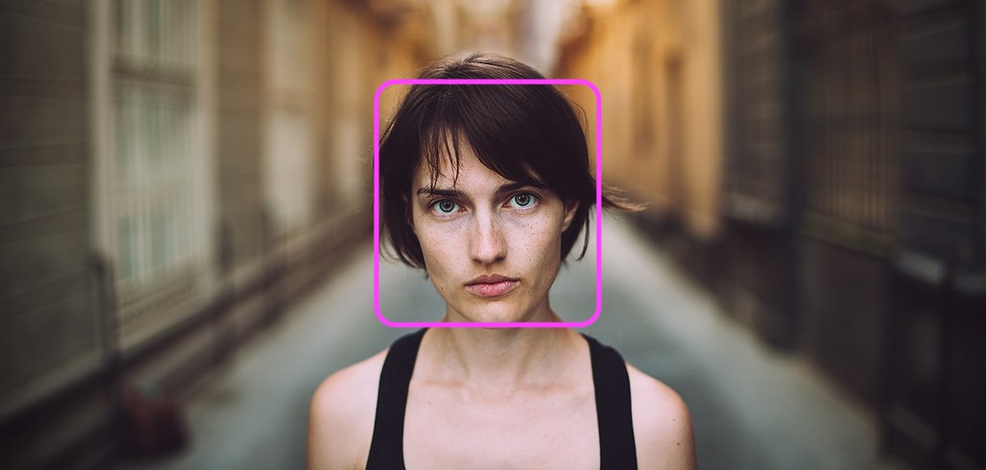  
  
A facial recognition system is a technology capable of [identifying](https://en.wikipedia.org/wiki/Identification_of_human_individuals) or [verifying](https://en.wikipedia.org/wiki/Authentication) a person from a [digital image](https://en.wikipedia.org/wiki/Digital_image) or a [video frame](https://en.wikipedia.org/wiki/Film_frame) from a [video](https://en.wikipedia.org/wiki/Video) source. There are multiple methods in which facial recognition systems work, but in general, they work by comparing selected [facial features](https://en.wikipedia.org/wiki/Face) from given image with faces within a [database](https://en.wikipedia.org/wiki/Database_management_system). It is also described as a Biometric Artificial Intelligence based application that can uniquely identify a person by analysing patterns based on the person's facial textures and shape  
  
While initially a form of computer [application](https://en.wikipedia.org/wiki/Application_software), it has seen wider uses in recent times on mobile platforms and in other forms of technology, such as robotics. It is typically used as access control in [security systems](https://en.wikipedia.org/wiki/Burglar_alarm) and can be compared to other [biometrics](https://en.wikipedia.org/wiki/Biometrics) such as [fingerprint](https://en.wikipedia.org/wiki/Fingerprint) or eye [iris recognition](https://en.wikipedia.org/wiki/Iris_recognition) systems. Although the accuracy of facial recognition system as a biometric technology is lower than [iris recognition](https://en.wikipedia.org/wiki/Iris_recognition) and [fingerprint recognition](https://en.wikipedia.org/wiki/Fingerprint), it is widely adopted due to its contactless and non-invasive process. Recently, it has also become popular as a commercial identification and marketing tool. Other applications include advanced human-computer interaction, video surveillance, automatic indexing of images, and video database, among others.

So, The Top most computer programming languages for face recognition or face detection are:  
  
1) [OpenCV](https://opencv.org/)  
  
[](https://opencv.org/)  
  
[OpenCV (Open Source Computer Vision)](http://opencv.org/) is a popular computer vision library started by [Intel](http://www.intel.com/) in 1999. The cross-platform library sets its focus on real-time image processing and includes patent-free implementations of the latest computer vision algorithms. In 2008 [Willow Garage](http://www.willowgarage.com/) took over support and OpenCV 2.3.1 now comes with a programming interface to C, C++, [Python](http://www.python.org/) and [Android](http://www.android.com/). OpenCV is released under a BSD license so it is used in academic projects and commercial products alike.  
  
2) [MATLAB](https://www.mathworks.com/products/matlab.html)  
  
  
[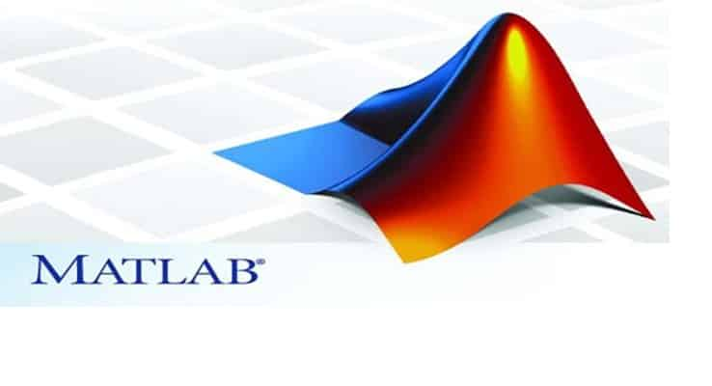](https://www.mathworks.com/products/matlab.html)Matlab is one of best popular programming language for Robots and Artificial Intelligence in the world. It is majorly used for Instrumental Devices and Human Recognitions.  
  
You can visit by clicking this link to get more information:  
  
<https://www.mathworks.com/discovery/face-recognition.html>  
  
  
3) [Python](https://www.python.org/)

[](https://www.python.org/)  
  
Python is a general-purpose interpreted, interactive, object-oriented, and high-level programming language. It was created by Guido van Rossum during 1985- 1990. Like Perl, Python source code is also available under the GNU General Public License (GPL). This tutorial gives enough understanding on Python programming language.You can get more detail about this of Python on:  
<https://pypi.org/project/face_recognition/>  
  
THANKS YOU,

For more helpful and useful posts, visit our blog by clicking here

<https://learn-all-about.blogspot.com/>

SHARE THIS POST TO SHARE FREE KNOWLEDGE FOR ALL.  
  
"FOR MORE USEFUL AND HELPFUL KNOWLEDGE POSTS,STORIES ,BIOGRAPHIES AND CASE STUDY THAN FEEL FREE TO SUBSCRIBE OUR BLOG.."

For more helpful and useful posts, visit our blog by clicking here

<https://learn-all-about.blogspot.com/>